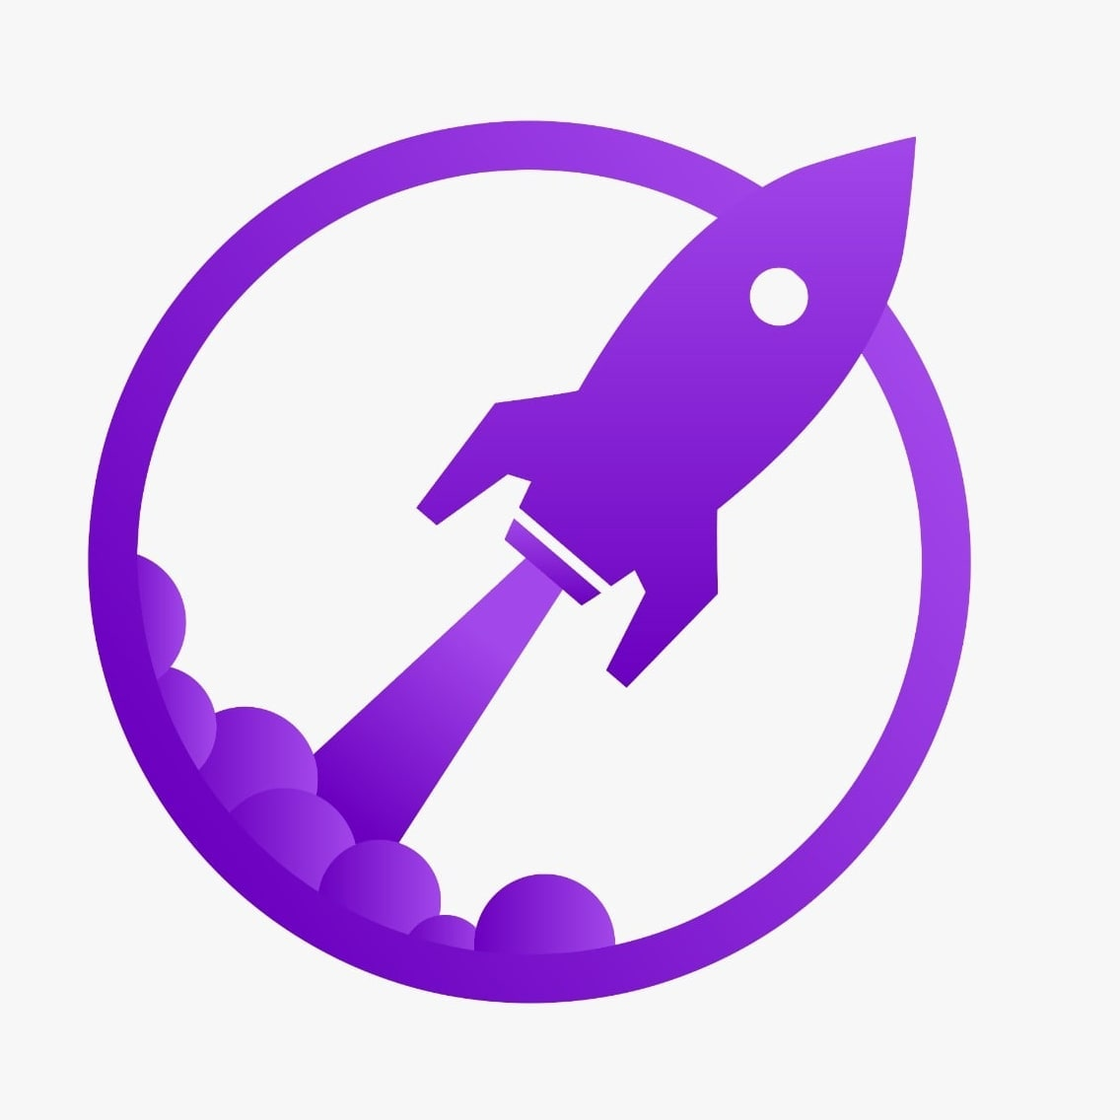

**NextDNA Edutech LLP.**

Hyderabad, Telangana

**Website**: https://www.scientificparks.com/

**Phone**: +91 8074032642

**14th August 2023**

**INTERNSHIP COMPLETION CERTIFICATE & RECOMMENDATION**

We are pleased to acknowledge that Ashutosh has worked with our organization as a Full Stack Web Developer intern from 4th July 2023 to 4th August 2023.  
  
We are pleased to acknowledge the successful completion of your internship at NextDNAEdutechLLP. We extend our heartfelt appreciation for your valuable contributions and dedication during your time with us as a Full Stack Web Developer intern.  
  
During the entirety of your internship, you consistently showcased a robust passion for web development and proactively embraced the opportunity to acquire new skills. Notably, you eagerly delved into technologies such as Next.js, TypeScript, JavaScript, as well as utilized tools like Sanity CMS for content management and Vercel for deployment. Your genuine enthusiasm permeated your work, clearly manifesting through the innovative concepts you introduced and your proactive engagement across multiple projects..  
  
You consistently exhibited a high level of professionalism, adaptability, and a willingness to take on challenges. Your technical skills, especially in front-end and back-end development, greatly enriched our team's capabilities. Your ability to collaborate effectively with senior developers and designers showcased your excellent teamwork and communication skills.  
  
Your contributions to project discussions, code reviews, and problem-solving sessions were highly valuable and greatly appreciated. We were particularly impressed with your commitment to meeting project deadlines and your willingness to put in extra effort when required. Your dedication and strong work ethic positively influenced the overall productivity and atmosphere of our development team. It is evident that you have grown significantly as a Full Stack Web Developer during your internship, and we believe that you are well-equipped to excel in your future endeavors. We have no doubt that your passion, skills, and determination will lead you to continued success in your career.  
  
We wish you all the best in your journey ahead, and we remain open to any potential collaboration or reference requests. Please feel free to contact us at nextdnaedutech@gmail.com or 8074032642 if you have any questions or if there is any way we can support your future endeavors.  
  
Once again, congratulations on successfully completing your internship. We are confident that you will achieve great heights in your career.

For **NextDNA Edutech LLP.**



Upendar Rao Gunda

Co-Founder, CEO

Hyderabad, India